

Career Ready Funding Guidelines
2026

About the fund

The Career Ready Fund is a pot of money to help give young people with learning disabilities good and real experiences of work.


The fund will give money to groups that give very good support and career support to young people in both Special Education or Mainstream schools (SEND).


We would like groups that are person centred and help young people with learning disabilities to look for jobs, have good work experience, and help to get a paid job to apply for this pot of money.


We want groups to apply for this funding who really work with their community and give supported employment to young people with learning disabilities. You may already do this work or want to start doing work like this.


We’re looking for groups that work as a team with schools, families and
employers to help young people have the confidence to have a career and get a paid job.


We want people as young as 14 to be part of this work so they have the time and support to get a good career and have a paid job.


What we want this funding to:

Job Coach

- Have job coaches in schools so young people can get person centred support at a young age around employment.


- Help to set up lots of work experience for young people to have work experience.


- Help young people put real plans in place for careers and look at the
things people are good at and raise young people hope and dreams for their future career.


- Set up a good team working with schools, the young person support network, and making sure young people are in supported paid employment.


- Look at clear ways into support internships, employment and paid work.


This funding is part of our “building independence programme” we support services that help young people do well as they become adults.

You can find out more on our website.



Fund details

How much money we will give your group:


We will give your group £200,000 over 4 years. This means you will get £50,000 a year.

= 4 years


You can apply for this funding from the 22nd of July 2026, from 9am.


You have until the 2nd of September 2026, until 5 pm to send your application form for this fund.

This funding is to get job coaches and keep them there. How you spend the money to do this is up to you.

Job Coach


We understand that groups will be starting from different places.



If you need time in the first year to get employ, train or build the right team before you can run this funding then that’s OK.


You could use this funding to:

- Employ a new job coach or train a member of your team to do this role

- Pay for more training for people to become job coaches

- Pay the job coaches’ wages

- Run and give one-to-one support to job coaches

- Pay for travel or anything the person needs to do their job and to communicate with their employer.

- Pay for core cost, such as rent, wages, bills, and making sure staff have support with mental health and wellbeing


We don’t tell you how to spend the money, because different organisations and people need different support.


Please allow for wages to go up once a year.

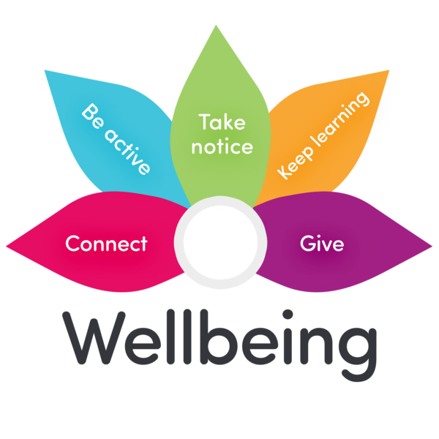
Please tell us what you do to support your team’s wellbeing.

Eligibility Criteria – Who can apply

Your organisation needs to:

- Be a charitable organisation registered in and working in the UK,
- Registered charities and Charitable Incorporated Organisations (CIOs)
- Community Interest Companies (CICs) that are not-for-profit with an asset lock
- Other not for profit charitable organisations running work that is similar to our aims.


- Have a years of accounts that have been audited or checked by another organisation.



Less than
£3 million
- Have annual income below £3m in your most recent accounts.

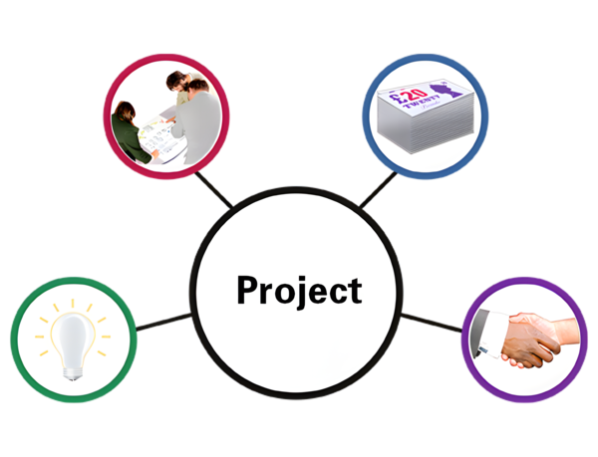
- Have run projects like this and worked with young people with learning disabilities.


- Run supported employment that is built on the supported employment model, led by trained (or trainable) job coaches.


We won’t fund:

- Work that is outside UK

- Work that has already taken place

- Work that is for the benefit of a person or a family

- Work that is not legally charitable

- Local authorities or work

- Activity that is about religion

- Employability or services that give information advice and guidance

- Work supporting people that don’t have a learning disability

- Schools


Don’t know if you can apply?

We’re happy to talk it through. Contact us for a chat.

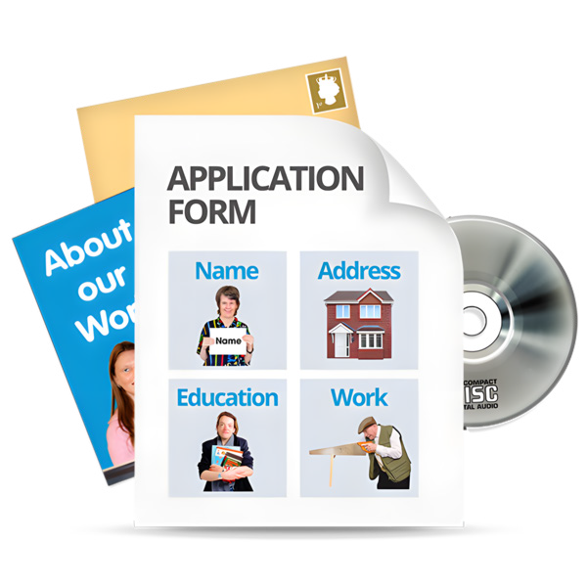
How to apply

The picture below tells you the steps to applying.

Eligibilty quiz
Expression of interest
Full application
A
conversation with us
Grants awared


Eligibility quiz

Take the short quiz on our website to check if you can apply. The Fund opens on 22nd July 2026, 9am.

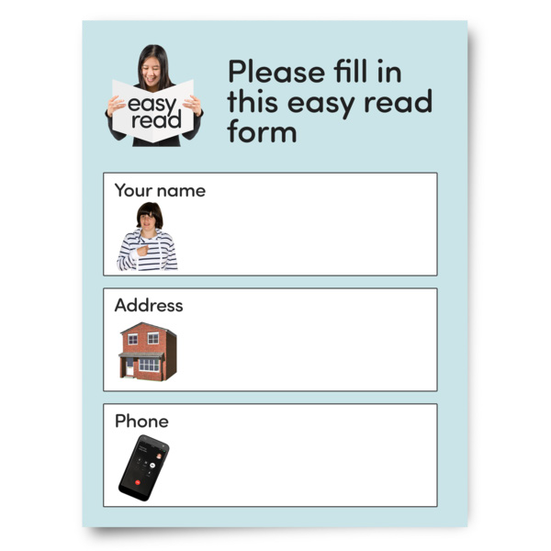
Expression of Interest (EOI)

If you think you can apply then before you send a full application. Please fill out our short form this is also called an Expression of Interest (EOI).


This has 3 questions. You can find an example on our website.


Deadline: 2nd September 2026, 5pm We’ll tell you by 25th September 2026 if we would like you to fill out a larger form.

Full application

If we ask you to apply, we will ask you to fill out our big form. This will ask you about your work, your team and how you change peoples lives.


We will also have to check some things about your organisation. Click here to read a sample application on our website. Deadline to submit full application: 26th October 2026, 5pm

We’ll arrange a call


You’ll have a call with a member of our team to:

- Learn more about your work and safeguarding processes

- Give you a chance to ask questions

When: 26th October – 13th November 2026

Grant decision


We’ll give you a decision on your application by 4 December 2026. Your grant must be started within 12 months of the date that the grant was awarded.


What happens if you’re unsuccessful?

At every stage of the process, if we decide not to fund your application, we will tell you why in writing.

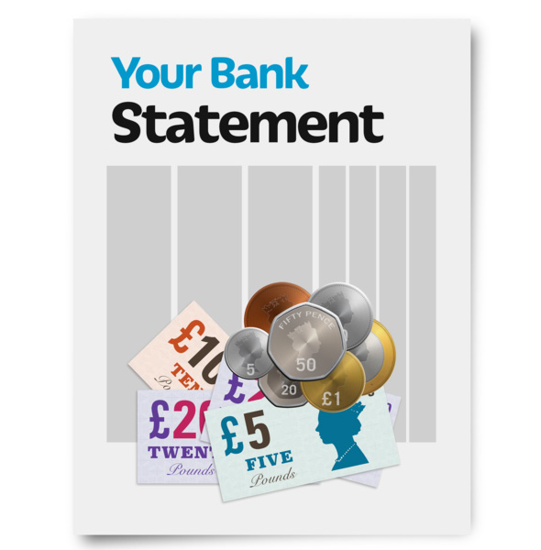
What happens if you’re successful
You will be asked to send us a copy of your bank statement dated from the last 3 months. We will ask for your Sort Code, Account Number, and Account Name.


By sending this, you are accepting the Terms in your offer letter.

Annual Learning Call

We’ll arrange a yearly call to check in on how your work is going, we will also ask you to fill out a short report about your work.


Mid-grant visit

In the second or third year of your grant, we’d like to visit to get to know your work better, meet your team and see your work.


Final report

At the end of the project you will need to fill out final report telling us how your grant has gone. You can download a sample report form to see the questions we ask.

Get in touch
We’re here to help. If you have any questions, please get in touch.

 Call us on: 020 7264 4970

Email: buildingindependence@ henrysmith.foundation


Questions

Please check our frequently asked questions (FAQs) before applying.

Artificial Intelligence (AI)


We know lots of organisations are using AI tools, and you can use them when filling out your application but they sometimes make it hard for us to see what makes your organisation special.



Its a good idea to always check the information AI gives and make sure it is used as a support but not to change your organisation’s own voice or story.

You can read our full guidance on our website.


Webinar

We’ll be holding a webinar to share more about the Career Ready Fund. You can ask us questions at this webinar.


Date: 21st July 2026, 11-12pm

Register: https://events.teams. microsoft.com/event/34aed0fb-cb08-4427-9a83-76ee3b7bafbe@8b63492b-8ac3-46f9-bc35-f7b7ceb0c214

Can’t attend? A recording will be on our website.

Accessibility Support


We want to make applying for this fund accessible to everyone. If you, or someone in your organisation, needs support to fill out the application we can help.


You can ask for: Up to £250 at the Expression of Interest (EOI). And up to

£250 EOI OR
£500 Full Application
£500 at the Full Application stage


If you need support - Get in touch and tell us what you need.

You can contact us by:
 Email: buildingindependence@ henrysmith.foundation
 Phone: 020 7264 4970 and ask for a callback.

When you get in touch, tell us:

- Your name and organisation
- What kind of support you need
- Who will provide the support (they must be in the UK)
- How much it will cost (up to the amount)
- How to get in touch with you

We will get back to you

We try to get back to people within five working days


If you do not know what kind of support you need or want to talk it through, we’re happy to have a chat. Please get in touch.

