Ten key principles for culturally competent support
Source: Alliance for Youth Justice
Guidance summary

Ten key principles for culturally competent support
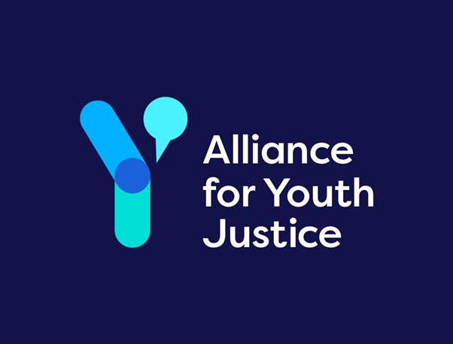
This summary is adapted from Alliance for Youth Justice’s report Bridging gaps and changing tracks: Supporting racially minoritised young people in the transition to adulthood in the criminal justice system. It is not a Henry Smith Foundation document or guidance.

1. Developing Positive Identities
- Take a strengths-based approach focused on empowerment, potential and opportunity.
- Support the development of a pro-social identity, exploring identity-related issues.
- Examine masculinity, vulnerability, mindfulness and reflection.

2. Being Age-Appropriate
- Provide developmentally appropriate support for older children and young adults.
- Use a fluid approach looking at needs and capacity, not just age.
- Recognise maturation continues into the 20s.

3. Bridging Gaps
- Support stays with the young person through transitions.
- Build a strong, trusted long-term relationship.
- Help young people navigate new systems and processes.

4. Challenging Structural Barriers
- Practitioners confidently talk about racism and structural barriers.
- Understand institutional racism and intersectionality.
- Challenge racial bias affecting young people's experiences.

5. Being Relatable
- Young people relate to practitioners they find credible and relevant.
- Lived experience can deepen understanding.
- Race can matter, but authenticity and motivation matter most.

6. Being Passionate
- Young people value genuine care and interest.
- Practitioners should be passionate about this age group.

7. Being Community-Based
- Support is local and community-rooted.
- Practitioners understand local issues and assets.
- Meet young people where they are.

8. Meeting Specific Needs
- Identify and address vulnerabilities in racially minoritised young people.
- Provide multi-agency support, including speech and language therapy and mental health.
- Address housing, financial instability, exploitation, and re-engagement.

9. Hearing and Standing Up for Young People
- Co-create support with young people.
- Embed their experiences into policy and practice.
- Advocate for their rights and needs.

10. Being Non-Authoritarian and Independent
- Support feels independent from systems that have failed them.
- Avoid directive, authoritarian approaches.
- Build trust through openness and respect.

