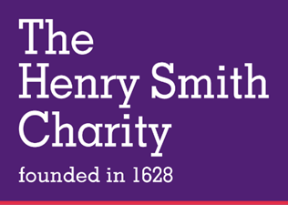

Requesting a review of your Kindred Application
If you disagree with the decision made on an application for a grant, there is no right of appeal. However, you can ask for the decision to reviewed. You can do this in writing or by telephone, using the contact details below.
The application will be reviewed by The Kindred Grants Programme Manager, or if they have made the original decision, it will be reviewed by another decision maker within the Kindred Team. They may ask for more information or evidence to complete a thorough review. Trustees will be informed throughout the review and be responsible for the final decision.
We aim to review the decision and provide an outcome within 15 working days.
The decision of the Trustees is final.

Email: kindred@henrysmithcharity.org.uk
Tel: 020 7264 4970 (Option 2)
The Henry Smith Charity
Caledonia House, 3rd Floor
223 Pentonville Road
London N1 9NG

